Three-tier architecture with CURD operation

In this lab, we will learn how to create 3 tier architecture application using asp.net with c#.
Basically three tier architecture means our project divided into three main layers or we can also say our project developed and maintained in to three separate layers.
1. Presentation Layer (UI – User Interface Layer)
2. Business Logic Layer (use for write logic code)
3. Data Access Layer (DAL use for connectivity with Database)

First lets understand main three layers of three tier architecture:
1. Presentation Layers or User Interface Layer
– Presentation layer is a user interface layer where we can design our web page or windows page. It is basically our .aspx page or Html page where we can make design with controls. UI is a intermediate between user and business logic layer. In other simple word we can say Presentation layers where user can give input and get some result as output.
2. Business logic layer (BLL)
– Business layer is intermediate or middle layer that communicate presentation layer and Data access layer.
Business layer used to validate input condition and correct the date before calling method from the data layer.
In Business layer we can write our business logic code and validation code as per the project requirements.
3. Data Access Layer (DAL)
– Data Access Layer used to make connection with database server. In data access layer we can write database query, stored procedure for insert, update, delete, select operation on database.This layer only communicate with Business logic layer.

- Create application by selecting asp.net empty web form
- Add a web form into application and name it “Default.aspx”
- Add below code into Default.aspx file

<%@ Page Language="C#" AutoEventWireup="true" CodeFile="Default.aspx.cs" Inherits="_Default" %> <!DOCTYPE html PUBLIC "-//W3C//DTD XHTML 1.0 Transitional//EN" "http://www.w3.org/TR/xhtml1/DTD/xhtml1-transitional.dtd"> <html xmlns="http://www.w3.org/1999/xhtml"> <head runat="server"> <title>Three Tier Architecture in ASP.Net</title> </head> <body> <form id="form1" runat="server"> <div> <table> <tr> <td colspan="2"> 3-tier User Registration Form</td> </tr> <tr> <td> Name :</td> <td> <asp:TextBox ID="txtname" runat="server"></asp:TextBox> </td> </tr> <tr> <td> Address : </td> <td> <asp:TextBox ID="txtaddress" runat="server"></asp:TextBox> </td> </tr> <tr> <td> City : </td> <td> <asp:TextBox ID="txtcity" runat="server"></asp:TextBox> </td> </tr> <tr> <td> Email : </td> <td> <asp:TextBox ID="txtemail" runat="server" style="height: 22px"></asp:TextBox> </td> </tr> <tr> <td> &nbsp;</td> <td> <asp:Button ID="Button1" runat="server" Text="SAVE" /> </td> </tr> </table> </div> </form> </body> </html>

- Add Class library into project solution
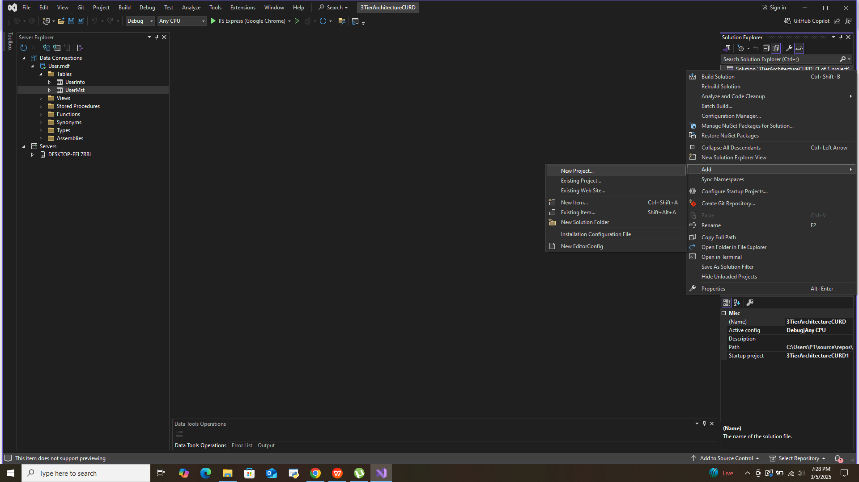

- Add following code into class library data layer

using System;
using System.Data;
using System.Data.SqlClient;

namespace DAL

{
public class Class1
{
}

public class ClsDataLayer
{
SqlConnection SqlConn = new SqlConnection("Data Source=(LocalDB)\\MSSQLLocalDB;AttachDbFilename=C:\\Users\\P1\\Documents\\User.mdf;Integrated Security=True;Connect Timeout=30;Encrypt=True");

public void InsertData(string _name , string _city, string _email )
{

SqlDataAdapter SQLAdp = new SqlDataAdapter("Insert into UserMst values ('" + _name+ "','" + _city + "','" + _email + "')", SqlConn);
DataTable DT= new DataTable();
SQLAdp.Fill(DT);

}

public object SelectData()
{
SqlDataAdapter SqlAdp = new SqlDataAdapter("Select * from UserMst ", SqlConn);
DataTable DT = new DataTable();
SqlAdp.Fill(DT);
return DT;
}

}
}

- Add another class library intro project for business layer logic
- Add DAL class reference into BLL class
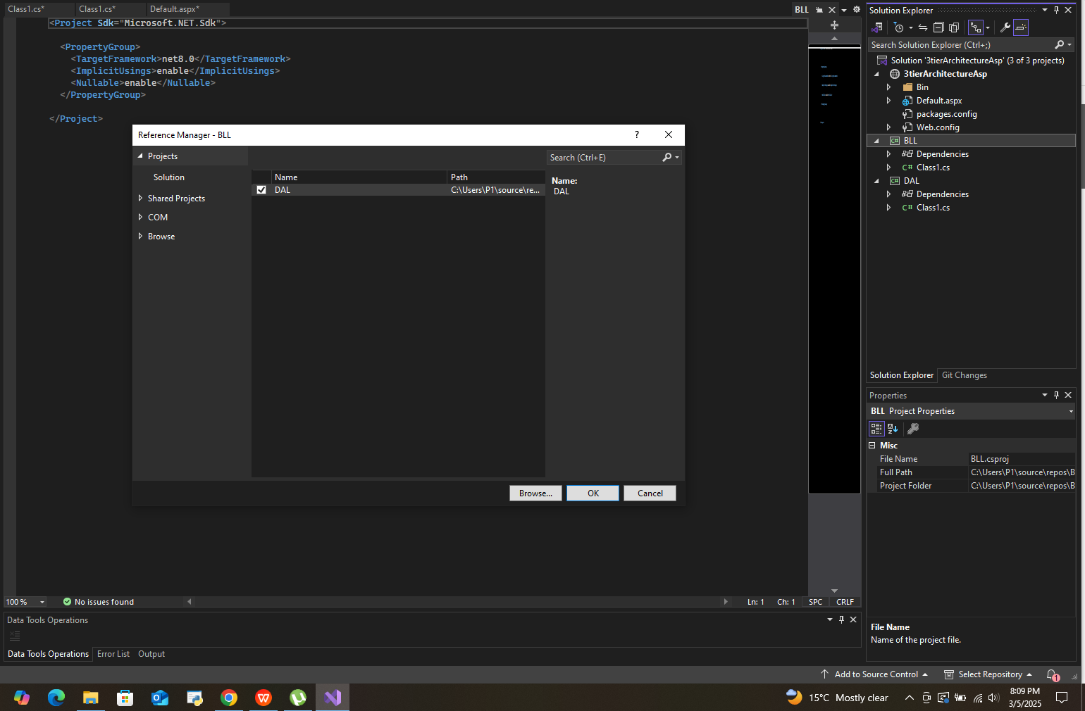
- Add code into BLL class

using DAL;

namespace BLL
{
public class Class1
{
}

public class CLSBussLayer
{
ClsDataLayer objDal = new ClsDataLayer();

public void InserUser (string _name , string _city, string _email)

{
objDal.InsertData(_name, _city, _email);

}

public object SelectUSer()
{

return objDal.SelectData();

}

}
}

- Add code into presentation layer

using System;
using BLL;

public partial class _Default : System.Web.UI.Page
{
protected void Page_Load(object sender, EventArgs e)
{

}

protected void Button1_Click(object sender, EventArgs e)
{
CLSBussLayer objBLL = new CLSBussLayer();
objBLL.InserUser(txtname.Text, txtcity.Text, txtemail.Text);

GridView1.DataSource = objBLL.SelectUSer();
GridView1.DataBind();
}
}

